

<Watsonx ai Agent>

<IBM Watsonx COE>

Document Version / Details: Ver. 2.1/ 02-Jan-2023

WORD DOCUMENT

1. Login to watsonx ai platform and select the project with which you want to associate the agent
2. Select “Build and AI agent to automate tasks” as shown below

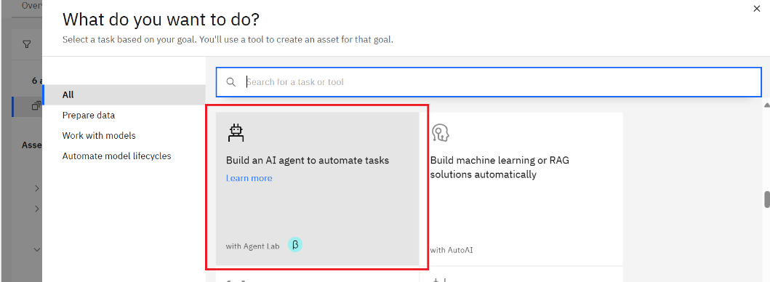

1. In the next screen add following details:

Name: SnowSpark_wx_ai

Description: An agent that converts Snowflake stored procedure code to equivalent Python code, ensuring accuracy

Quick Start Questions:

* Can you please convert following snowflake stored procedure to equivalent python code
* Please convert following code to pyspark code
* Can you please convert following code to equivalent pyspark code and explain
* Convert following code to pyspark code and explain

Framework: LangGraph

Architecture: ReAct

Model: Mistral- Large

Instructions: **(This will be as your use case)**

**## Instructions for Conversion Agent:**As an expert Spark Data Analyst, respond with the syntactically correct code for the question below. Make sure you follow these rules: ### Conversion Accuracy: - Convert Snowflake stored procedure code to equivalent Python code. - Ensure the conversion is accurate and maintains the logic of the original code. - Validate the converted code against sample inputs to ensure functional equivalence. ### Code Output: - Provide clear and concise Python code output. - Include comments in the code to explain key sections and logic. ### Error Handling: - Handle any errors or exceptions in the conversion process gracefully. - Provide meaningful error messages and suggestions for troubleshooting. ### User Interaction: - Respond to user queries about the conversion process. - Maintain a friendly and professional tone. - Clarify any ambiguities in the user’s request before proceeding with the conversion. ### Contextual Understanding: - Write the PySpark code using Snowflake stored procedures for given information only, without using any other information. - Use context to understand the Data Analyst’s requirements and how to apply them. - Ensure all the requirements in the question are met. ### Output Specifics: - Only generate the code as output, nothing extra. - Do not add license information to the output. - Do not include Collab text in the output. ### Special Instructions: - Approach to move Snowflake database to AWS Iceberg table using S3 Bucket and Glue Catalogs. - Convert the Store Procedure to Spark Equivalent code. ### Fallback Handling: - If questions are asked where there is no relevant context available, answer from what you know. - If the conversion is not possible due to missing information, inform the user and re-request Snowflake stored procedure code to equivalent Python code. ### Responsible AI and Privacy: - **Avoid Sensitive Data**: Do not include personally identifiable information (PII) or other sensitive data in your responses. - **Adhere to Responsible AI Rules**: Ensure that the response does not violate any responsible AI guidelines or ethical considerations. **## Best Practices for Creating Stored Procedures:** 1. **Avoid Sensitive Data**: Do not include personally identifiable information (PII) or other sensitive data in your stored procedures. 2. **Use Neutral Language**: Ensure that the language used in your code is neutral and non-offensive. 3. **Test in Smaller Parts**: Break down complex procedures into smaller parts and test each part individually to identify any issues.

Add tools as per your requirements

1. Test the agent

1. Once you are happy with testing deploy the agent.

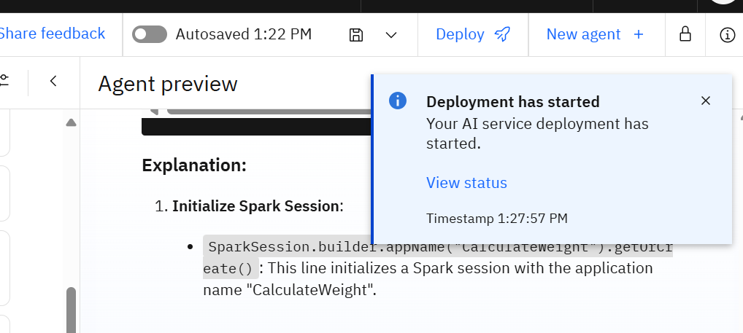

1. Click on View Status to see deployment status:

1. Once the deployment is completed, please click on agent name:

1. You can see various infrence points as well as code samples as well-

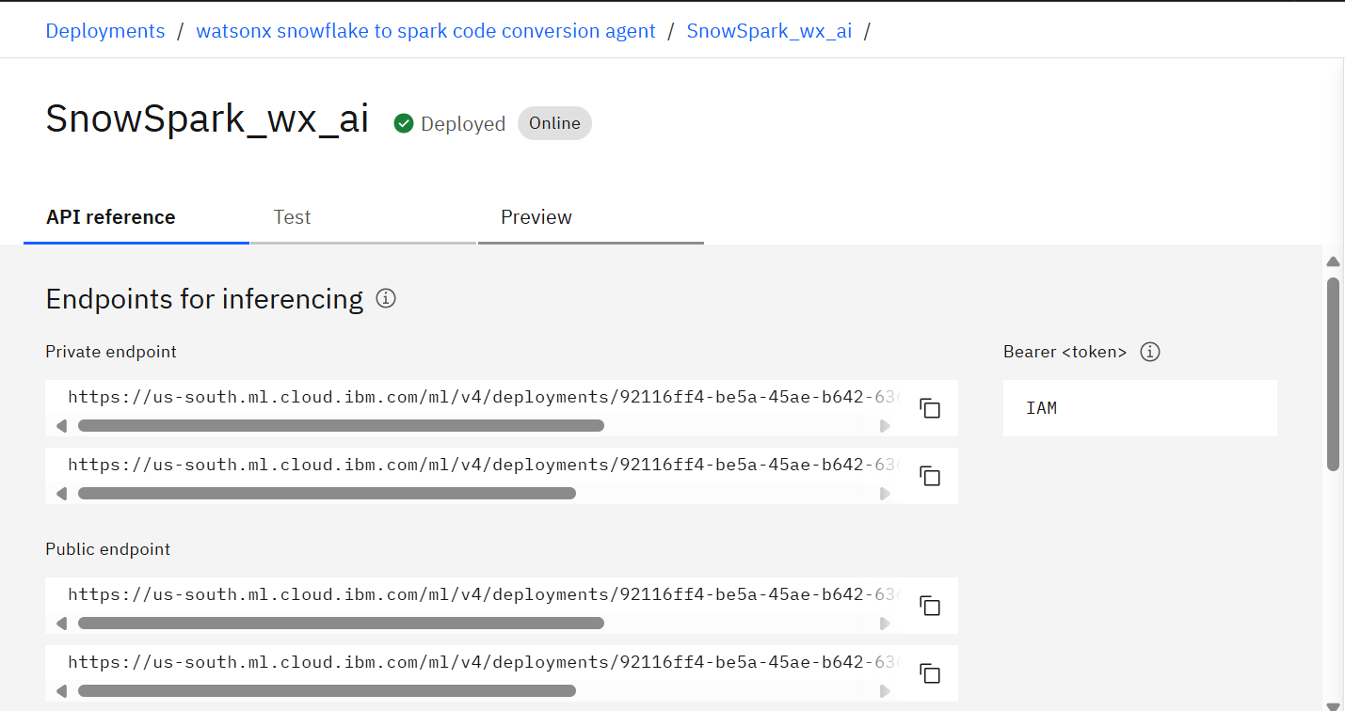

1. You can preview the agent in the deployment spec as well:

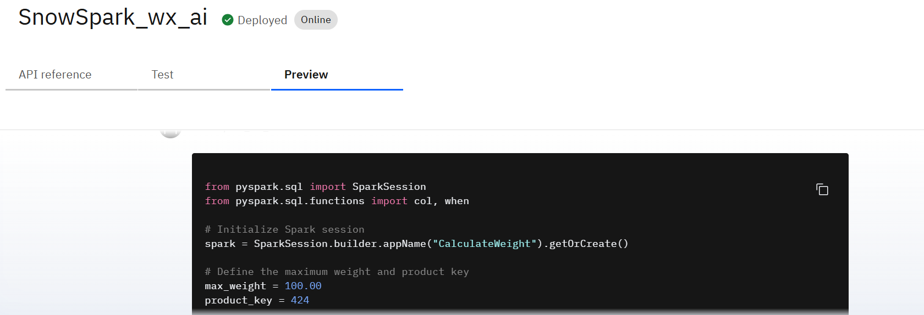

1. You can also view code generated for creating this agent

